**AWS Relational Databases**

* AWS Supports Relational Databases by a Service called as AWS RDS (Relational Database Service)
* AWS RDS Supports the following Database Engines
  + mysql
  + postgresql
  + oracle
  + Microsoft SQL Server
* Lets Navigate to the RDS  
  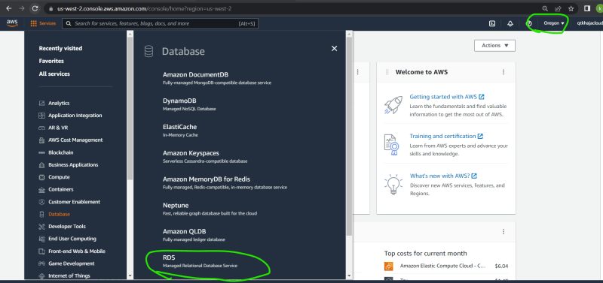  
  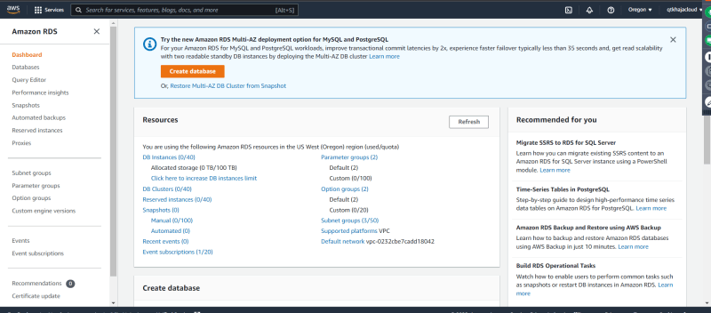
* Lets find out what is free w.r.t RDS  
  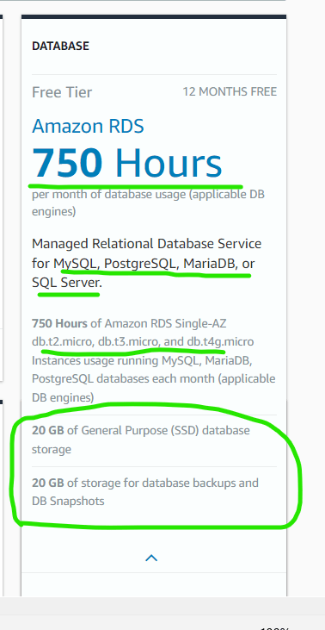
* Lets create a free tier eligible mysql database  
  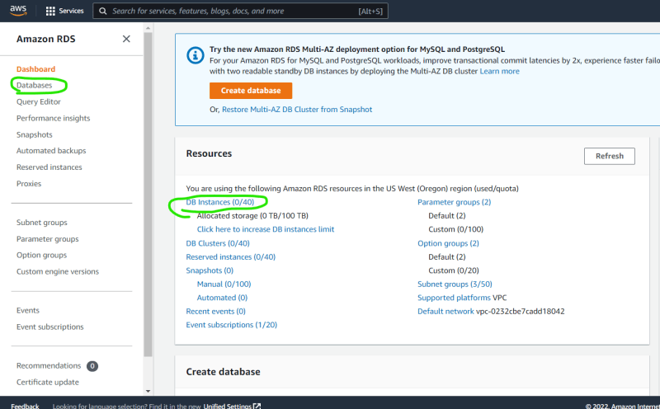  
  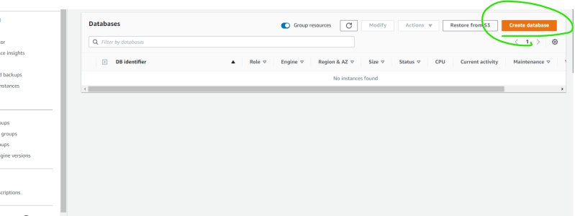  
  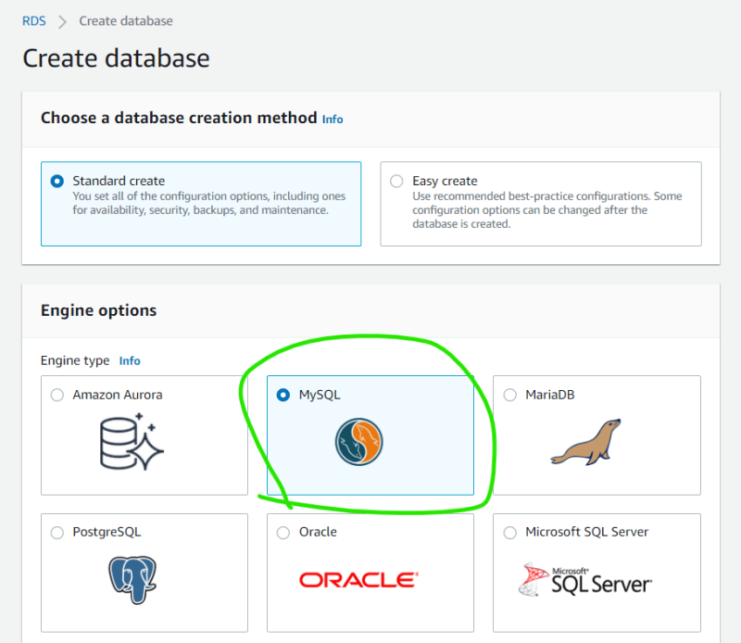  
  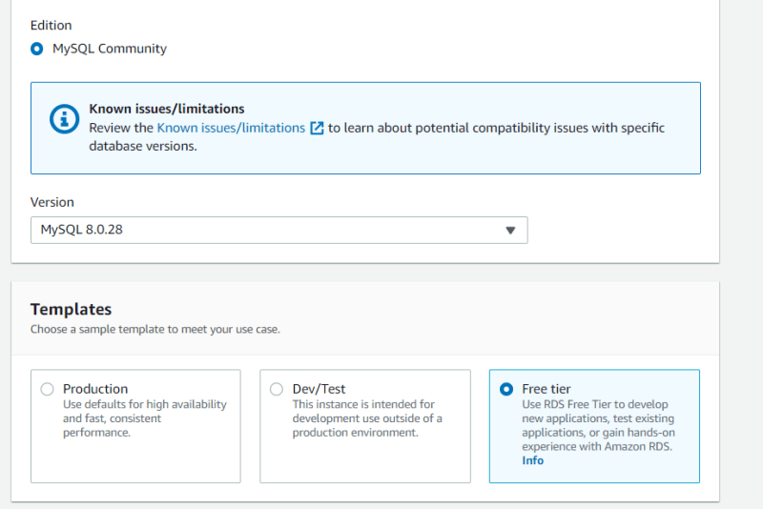  
  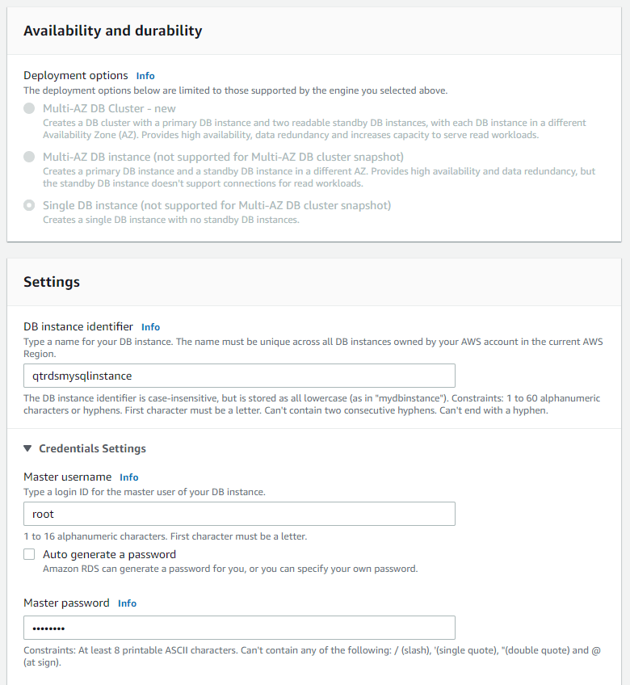  
  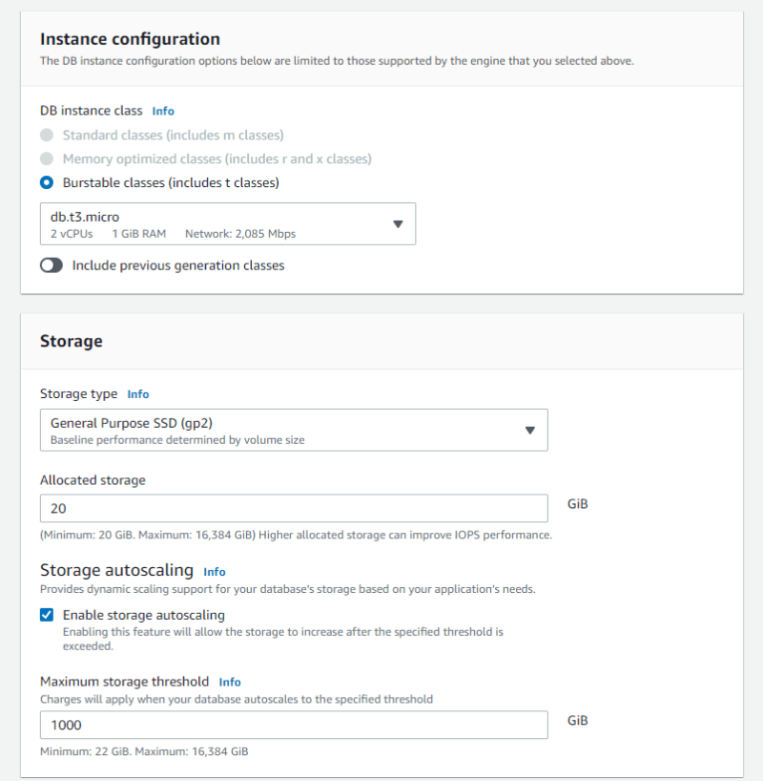  
  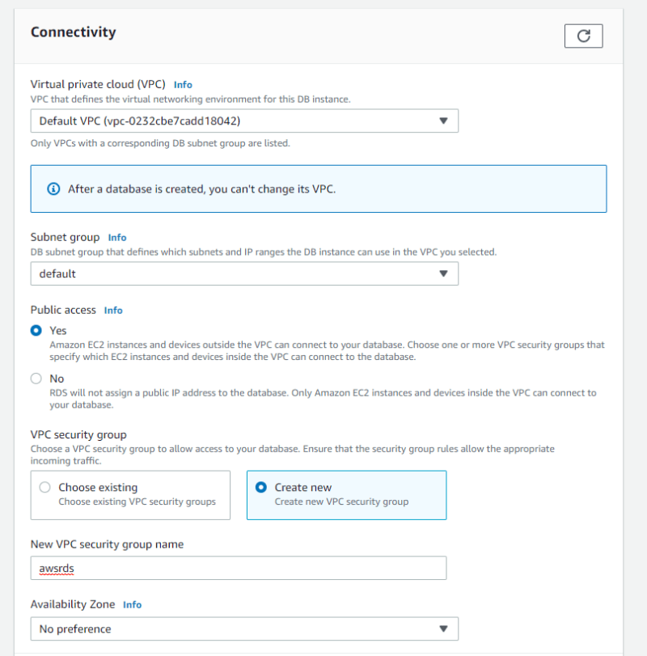  
  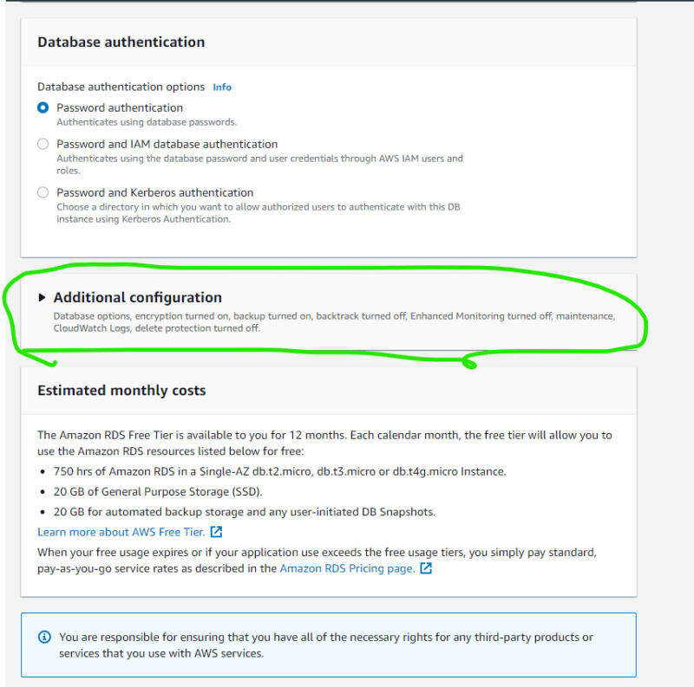  
  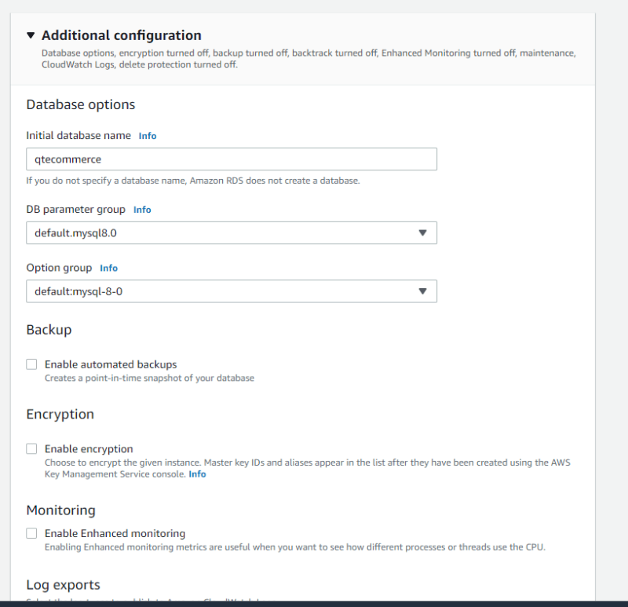  
  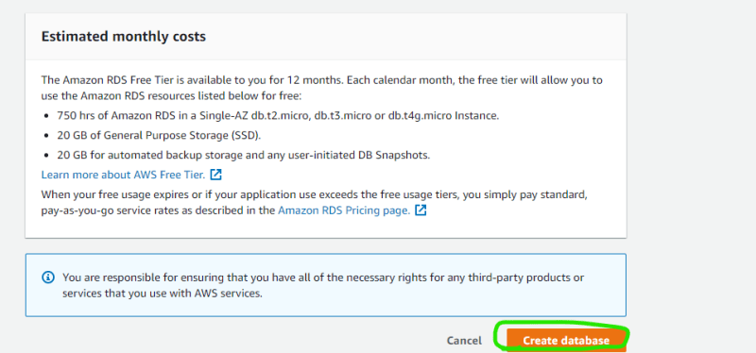  
  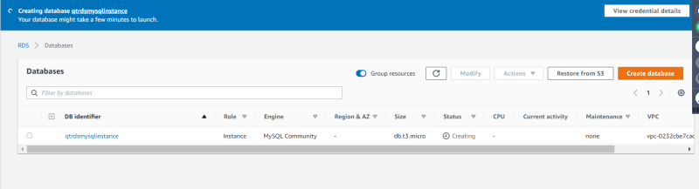  
  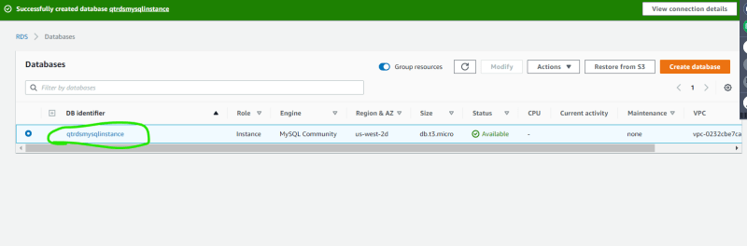  
  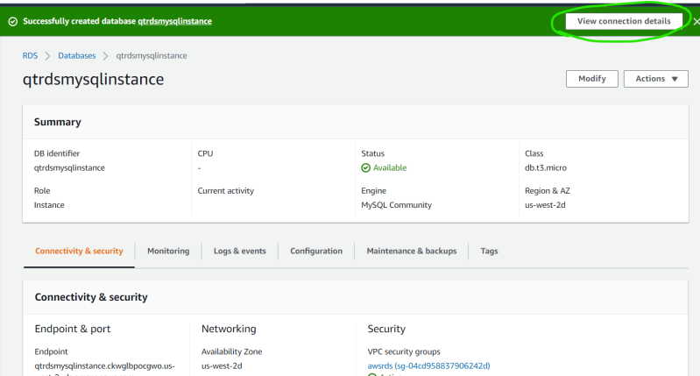  
  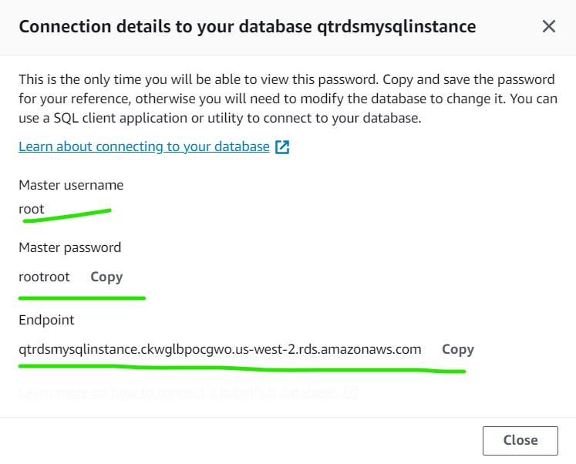
* Now lets navigate to firewall i.e. security group mysql works on port 3306 and open connection from anywhere
* To connect to a database we need db clients or code.
* mysql => mysql workbench [Refer Here](https://dev.mysql.com/downloads/workbench/)
* using mysql workbench connect to the db  
  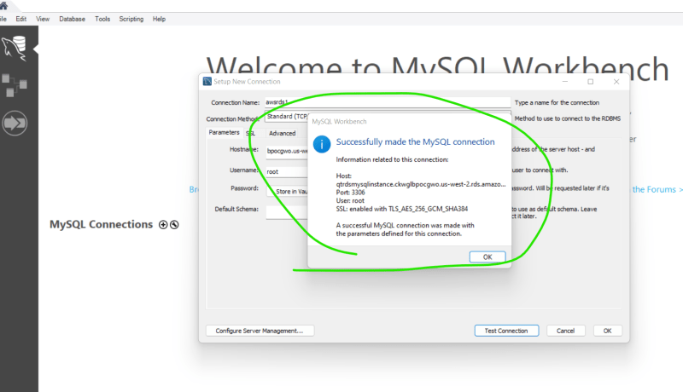  
  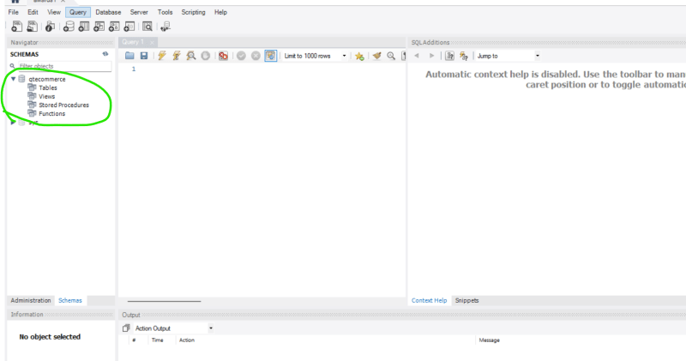
* Lets create a table and insert some data into it [Refer Here](https://www.sqlshack.com/learn-mysql-add-data-in-tables-using-the-insert-statement/)

use qtecommerce;

create table tblEmployee

(

Employee_id int auto_increment primary key,

Employee_first_name varchar(500) NOT null,

Employee_last_name varchar(500) NOT null,

Employee_Address varchar(1000),

Employee_emailID varchar(500),

Employee_department_ID int default 9,

Employee_Joining_date date

);

INSERT INTO tblEmployee (employee_first_name, employee_last_name, employee_joining_date) values ('Nisarg','Upadhyay','2020-06-26');

INSERT INTO tblEmployee (employee_first_name, employee_last_name, employee_joining_date) values ('Gopi','s','2020-06-26');

INSERT INTO tblEmployee (employee_first_name, employee_last_name, employee_joining_date) values ('Venkat','Anand','2020-06-26');

INSERT INTO tblEmployee (employee_first_name, employee_last_name, employee_joining_date) values ('Sukhen','Manna','2020-06-26');

Select * from tblEmployee;

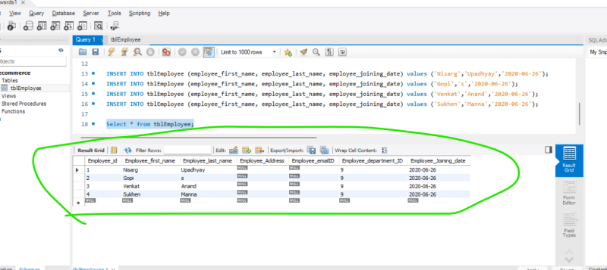

* Configuring Replication for a database is generally done by DBA’s lets see how to do this in AWS RDS  
  